The APS Title I Department Provides the following to the Parents at Title I Schools:

Support in or Access to:
- Materials and training to assist parents with strategies for working with their student(s)
  - Videos
  - Family Reading Programs
- Information about Common Core State Standards and assessments
- Information about Title I Programs/funding is given to parent/guardians at the schools’ Title I Annual Meeting and available upon request from the school principal (Funds are distributed directly to schools for family engagement)
- Advertisement regarding the Title I Annual Meeting in a variety of formats and languages (Spanish news and radio, marquees, newsletters and websites)
- Opportunity through district wide meeting to give input about the District Family Engagement Support Agreement and Procedural Directive. Parents/guardians always welcome to send ideas or suggestions about how Title I can improve family engagement by visiting or calling the Title I office.

Filing a Complaint
Parents/guardians with concerns should follow these steps:
- First talk with their child’s teacher
- Then the school principal
- APS Student Service Center
- Contact the APS Title I Department if the issue involves Title I services
- Contact the New Mexico Public Education Department if the issue is not addressed or resolved to your satisfaction
*The detailed complaint process is contained in the full version of the Family Engagement Process and Procedural Directive available at the school website or through the Title I Department.

Title I Family Engagement:
Dale Evan Hagin 253-0330 ext. 67013
Mail to: hagin_d@aps.edu
APS Student Service Center:
Main number 855-9040
Mail to: servicecenter@aps.edu

(Revised 4/2016)
Title I 2016-17 District Family Engagement Support Agreement
Parents/Guardians are encouraged to be involved with the Title I program at their school including how the Title I funds are spent.
The full Title I District Family Engagement Process and Procedural Directive and the Title I District Support Agreement are available on the APS website and at each school website or you may request the full version from the school or APS District Title I Department.
http://www.aps.edu/about-us/policies-and-procedurals-directives

The APS Title I Department Provides the following to Title I Schools:
Support in or Through:
- Title I Budget
- Compliance with Title I law
- District meetings on best practices
- Samples and materials to help develop.
  - School Family Engagement Policy
  - School Compact
- Planning Meetings related to Title I.
  - Title I Annual Meeting
  - Parent Meetings related to academic achievement
  - Leadership and/or Volunteer training for parent/guardians
- Making the Educational Plan for Student Success (Web EPSS) available on the school’s website or a paper copy in the school’s office for parent/guardian to review.
- Making the school’s Title I budget available on the school’s website or a paper copy in the school’s office for parent/guardian to review.
- Training for principals and staff in understanding Title I law as it applies to improving academic achievement, especially for those students at greatest risk of failure, and how family engagement plays a key role in that process.
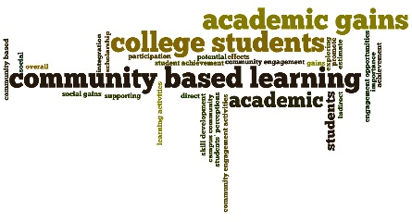
- Training for principals and staff specific to creating a welcoming environment
- Providing information about Common Core Standards and assessment
- Providing information, tools and assistance in order to value parent/guardians on committees and to reach out to all parents.
Such as:
  - Variety of programs
  - Meeting times to accommodate families
  - Methods of two-way communication
- Assuring all Title I related documents are available in all languages represented in a school’s community to the extent possible
- Distributing surveys through the APS Office of Accountability and Reporting (OAR) on the effectiveness of the school’s family engagement using surveys and data with family engagement committees to develop family engagement policies and identify barriers to participation by all parents/guardians

