- Provides information, tools and assistance in order to value parent/guardians on committees and to reach out to all parents.
Such as:
  - Variety of educational programs
  - Meeting times to accommodate families
  - Methods of two-way communication
- Assuring all Title I related documents are available in all languages represented in a school’s community to the extent possible
- Distributing the Family Engagement surveys both electronically and paper copy with the assistance of APS’ Research and Evaluation.
- Individual school survey results are used to study and improve family engagement at each Title I school site.

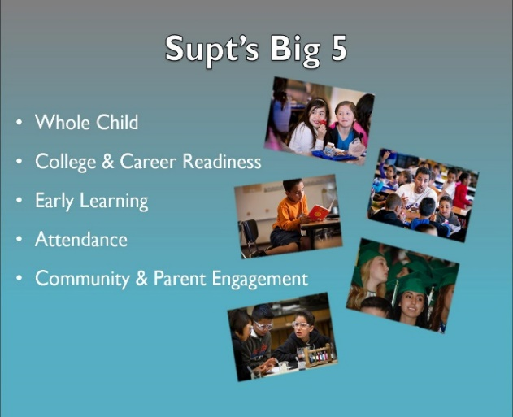 5

Do you have a Concern?

Filing a Complaint
Parents/guardians with concerns should follow these steps:

- First talk with their child’s teacher
- Then the school principal
- Call APS Student Service Center 505-855-9040
- Contact the APS Title I Department if the issue involves Title I services 505-253-0330
- Contact the New Mexico Public Education Department if the issue is not addressed or resolved to your satisfaction 505-827-5800

*The detailed complaint process is contained in the full version of the Family Engagement Process and Procedural Directive available at the school website or through the Title I Department.

Title I Family Engagement:
Nancy Davenport 253-0330 ext. 67017
APS Student Service Center:
Main number 855-9040
email to: servicecenter@aps.edu

(Revised 6/18)
Title I 2018-2019 District Family Engagement Support Agreement
Title I provides school districts with extra resources to help improve instruction to ensure that poor and minority children have the same opportunities as other children to meet today’s challenging academic standards.
Parents/Guardians are encouraged to be involved with the Title I program at their school including how the Title I funds are spent.
The Title I District Family Engagement Process and Procedural Directive and the Title I District Support Agreement are available on the APS Title I website, at each school website or you may request a printed copy from the school or APS District Title I Department.
http://www.aps.edu/title-i/family-engagement
The APS Title I Department Provides the following to parents at Title I Schools:

Family Support in :
- Making materials and training available to assist parents with strategies for working with their student(s) to boost academic success with fun and engaging events and programs
  - Family Reading Programs
  - Family Math Parties
  - Family Science Nights at Explora
  - Borrow Family Engagement DVD’s
  - Participate in Story time in the park
  - Increase your understanding your Students PARCC results
- Information about Common Core State Standards
- Information about Title I Programs is given to parent/guardians at the schools’ Title I Annual Meeting and available upon request from the school principal
- Opportunity through district wide meetings to give input about the District Family Engagement Support Agreement and Procedural Directive. Parents/guardians are welcome to send suggestions about how Title I can improve family engagement by visiting or calling the Title I office 2
How do I get involved?

Parents/guardians have a vital role in their students’ academic success. Communicate often with your student’s teacher(s), be interested in what they are learning and get involved.

Volunteering Opportunities:
- Classroom support
- Front Office
- Library
- Family Center
- Clothing Bank
- Mobile Food Pantry
- Tutor
- Homework Diner
- Career Day
- Be a guest speaker
- Ask the principal how you can help

Join:
- The PTA or PTO
- The school’s Welcoming Team
- Join your school’s Family Engagement Team
- Serve on your school’s Instructional Council.
- Serve on the Title I Family Engagement Advisory Council.
Call: Nancy Davenport 253-0330 ext. 67017

3
How does the APS Title I Department support Title I Schools?

- Title I Budget
- Compliance with Title I law
- Training and materials in developing
  - School Family Engagement Policy
  - School Compact
- Holds meetings related to Title I
  - Title I Annual Meeting usually during Open House
  - Parent Meetings linked to academic achievement often held at principal events
  - Family Engagement Liaisons hold educational trainings for parents/guardians.
- Ensures every Title I budget is made available on the school’s website.
- Provides training on creating a welcoming school environment.
- Provides training for Family Engagement Liaisons on how to support family engagement and the key role parents/guardians play in their students’ academic success.
- Provides information about Common Core Standards and assessment results.

Continue on back 4

